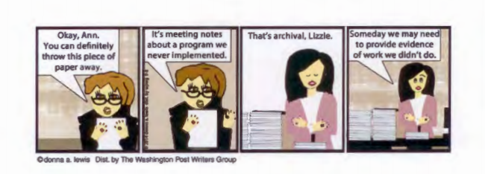

It's Okay, Ann.

meeting notes You can definitety

abourt a program we throw this piece of

never [ implemented.

=TM""'=

·Cdonna a. lewis Oist. by TM Wasflingtoo Posl Writers Group

That's archival. Lizzie. Someday we may need

I

of to work provide we evidence didn't do.